**Problem :** [**https://leetcode.com/problems/dungeon-game/**](https://leetcode.com/problems/dungeon-game/)

**Approach :**

=> dp[i][j] indicates the minimum negative score that the knight will get at any instant until the end, if he starts from grid[i][j]. So the knight will need abs(dp[i][j]) + 1 minimum score at the start of the game to survive,else it will become 0 or negative somewhere in between.

=> Off-course dp[0][0] will be out answer.

**=> dp[i][j] = grid[i][j] + max(dp[i+1][j] , dp[i][j+1]);**

**Key observation :**

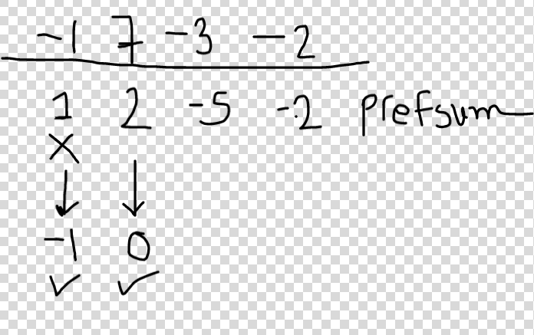

Lets consider 1 X 4 grid with elements -1 7 -3 -2 ,

when we calculate from behind, once the sum becomes positive that means from that position the knight requires 0 pnts (actually 0 + 1) minimum to start and not that positive value , so at that point make value 0 and then proceed else it will produce wrong answer.

so if dp[i][j] becomes positive reduce it to 0.

**Code :** [**https://leetcode.com/submissions/detail/543014603/**](https://leetcode.com/submissions/detail/543014603/)